Chapter 2: LITERATURE SURVEY
2.1 BOINC as a system of distributed artificial intelligence:
The BOINC (Berkeley Open Infrastructure for Network Computing.) is an open software platform (Berkeley University for GRID computing) − a non-profit middleware for organization of distributed computing. It is used for volunteer computing organization.
Figure 2.1 Scheme of BOINC work.
BOINC architecture (Fig. 1.3) is based on the idea of a distributed AI - its server consists of a set of individual subsystems (agents), each of which is responsible for its own well-defined task, such as performing of calculations, file transfer, etc. Each subsystem checks the status of sub-tasks produces some actions and changes the state of subtasks --- so they work in an infinite loop.
In general, the system consists of BOINC server, a plurality of clients, performing the tasks of the server and, possibly, additional components in the form of GRID-affiliated networks.
As we can see from the previous section, BOINC system, as well as any other system of distributed AI, existing at the moment, are the centralized systems, strictly managed by a central server, which, of course, is a significant drawback.
SONM system uses the BOINC system, which is a system of distributed intelligence as the basis for the creation of a decentralized intelligence. [8]

2.2 Swarm Intelligence and artificial life

The second direction − artificial life (AL) – is associated to a greater extent with the interpretation of intellectual behavior in the context of survival, adaptation and self-organization in dynamic, hostile environments, which goes back to the works by Piaget.

V.M. Bekhterev noticed that the more elementary goals and objectives of the collective, the more sizes the collective can reach. For example, man in a crowd of people loses inhibition ability, but wins in the imitative ones.
In the tideway of AL a global intelligent behavior of the entire system is considered as a result of local interactions of a large number of simple and not necessarily intelligent agents. Terms such as “collective intelligence” or “swarm intelligence” are also used for AL. Adherents of this direction, in particular, R. Bruks, J. Deneubourg, L. Steels, etc. rest on the following provisions: 1) the MAS is a population of simple and mutually dependent agents; 2) each agent independently determines its reaction to the events in the local environment and the interactions with other agents; 3) interrelations between agents are horizontal, i.e., there is no an agent-supervisor, managing the interaction of other agents; 4) there is no precise rules to define the global behavior of agents; 5) the behavior, properties and structure on the collective level are generated by only the local interactions of agents.
Here, mechanisms of reaction to the impact of the environment and local interactions in general case do not include aspects such as forecasting, planning, processing knowledge, but sometimes allow to solve complex problems. Typical biological examples of such collective intelligence include ant colonies, beehives, bird flocks, etc.
In program form, blockchain can serve as the most typical example of the existence of swarm intelligence − a lot of miners work as reactive agents, who without any control of agent-supervisor carry out the work on maintenance of the network, moving only in accordance with their own motivation.

The disadvantages of such systems consist of the inability of agents to the more complex organization, planning, and solution of the tasks, requiring sequential execution or data analysis, as well as the excess parallelism of tasks’ execution. [8]

Figure. 2.2 Collective Intelligence.

2.3 Decentralization With Google’s Federated Learning And Device-Centric AI
Centralized AI solutions provided as APIs and cloud-based services are great, but they have certain bottlenecks. Since users access AI features via the network and because ML algorithms involve heavy computations, high latency is often an issue. Also, if you train AI models in a centralized way, it may take more time to improve them. In contrast, decentralized AI can function locally on users’ devices, have access to more user data and have no dependence on a network connection, which means less power consumption and minimal latency. Recent advances in decentralized AI have been made thanks to on-device optimization of AI/ML for smart phones and production of dedicated chips for mobile AI and for desktops (e.g., Google’s TPU).
Decentralized AI gained powerful momentum in April 2017 after Google announced its new Federated Learning concept. This innovation signals a transition to fully decentralized learning and device-centric AI where machine learning models are trained directly on smartphones of users. Keeping the privacy of user data intact, Google can now outsource AI training to Android users, enabling on-device improvement of shared models. Federated Learning will solve the problem of high-latency and low-throughput connections where users have to connect to remote servers to use ML software. According to Google’s Brendan McMahan and Daniel Ramage, “Federated Learning allows for smarter models, lower latency and less power consumption, all while ensuring privacy.”
The move toward device-centric AI can also be seen in the release of Google’s TensorFlow Lite, a mobile version of a machine learning library fined-tuned to the computational and power constraints of smartphones. In June 2017, Apple followed Google’s lead by releasing its Core ML library for iOS devices. The library ships with the optimized general-purpose ML models and tools to convert third-party models into the iOS format. Making models available locally without a network connection will make it easier to develop mobile applications with AI functionality. According to Dave Burke, Google’s vice president of engineering for Android, these innovations “will help power the next generation of on-device speech processing, visual search, augmented reality and more.”
In the long run, a combination of AI DAOs, device-centric AI and decentralized learning will make AI more democratic and widespread than ever before. [4]

2.4 SingularityNET: The first decentralized AI marketplace

When discussing the combination of A.I. and blockchain, it would be borderline criminal not to mention SingularityNET.

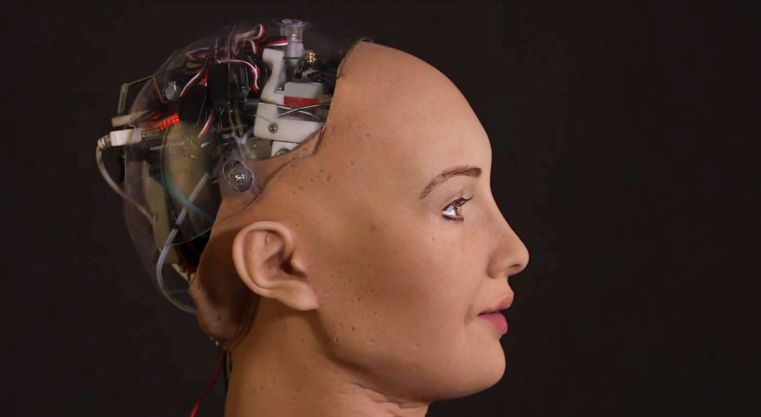

Figure 2.3 Sophia was the first robot to be granted, her intelligence is powered by SingularityNET
SingularityNET.io took the world by storm on December 2nd last year (2017), where they sold out their $36,000,000 hard cap in less than 70 seconds. The premise of the platform is to produce an A.I. marketplace where companies can buy and sell A.I. algorithms, machine learning tools and data sets on a global scale, facilitating growth of the industry.
Through the combination of open source principles, blockchain integration, and leveraging the leading minds in machine learning, SingularityNET intends to make AI accessible as a global commons for all.
Within the SingularityNET platform, agents can use AGI tokens to pay for A.I. related services, and these tokens can also be used to vote on decisions that can affect the future of the platform. SingularityNET really demonstrates that both A.I. and blockchain are technologies for the future. By bringing businesses that want to incorporate A.I. and A.I. researchers under one ecosystem, SingularityNET eventually hopes to develop an advanced general intelligence that can be applied to almost any task. [5]

2.5 Namahe — A.I. Supply chain
One of the major goals in most industries is to increase automation to increase efficiency and reduce costs, whether this be on the hardware side (e.g. Robotics), or on the software and logistics side via A.I.
Namahe is a platform that aims to massively overhaul the industries involved in the supply chain by incorporating an A.I. layer into the mix. Currently, supply chains are highly complex networks that connect consumers at the end of the chain, to the workers at start of the chain, via several intermediaries including manufacturers, suppliers and retailers. The problem with having so many layers, is that efficiency is often lost, partly due to lack of communication within the supply chain, and due to the speed at which it takes to respond to external events, such as changes in demand, or delays.
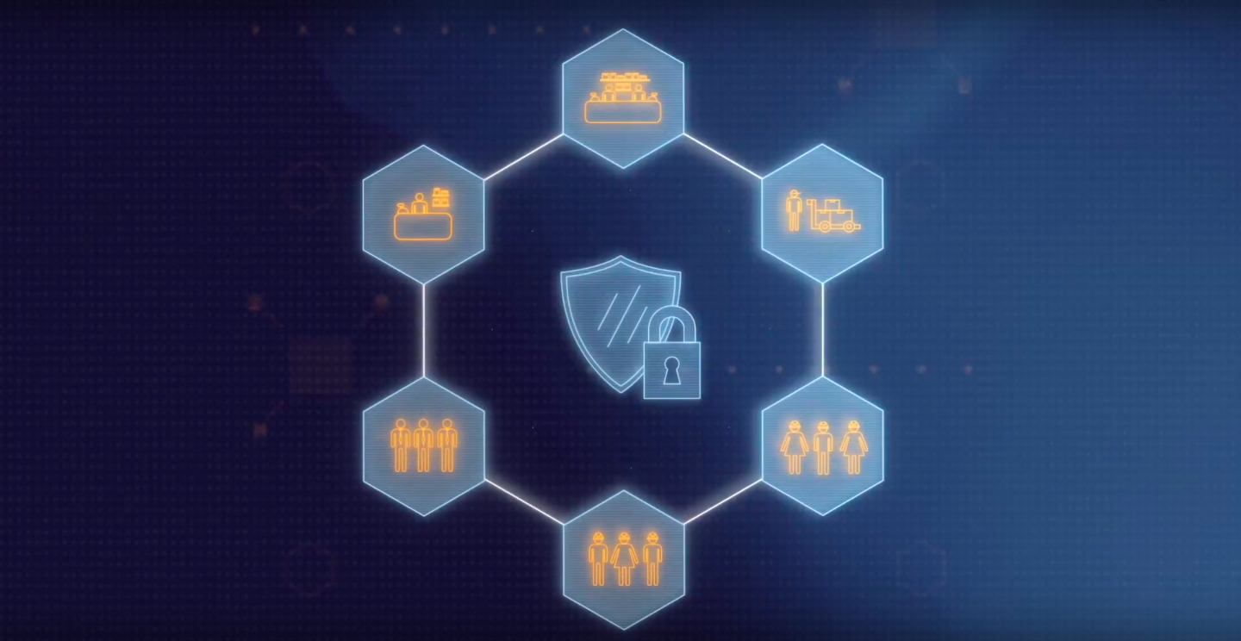
Figure 2.4 Namahe incorporates A.I. with blockchain technology
Over time, this system will expand its skill-set using machine learning libraries, and is expected to quickly reach a level where it can act autonomously, reacting to events much faster than previously possible based on the confidence of its observations, and eventually be capable of making predictions about future markets. [5]

2.6 Numerai — A.I. Hedge Fund
Did you know that many hedge funds already use machine learning and A.I. as part of their trading process? These systems tend to use historical data to forecast future conditions, which can give these hedge funds an edge in the high frequency and speculative trading spaces.
Unlike other hedge funds that use a closed loop, A.I. based analytics approach, Numerai instead opens its platform to the tens of thousands of data scientists around the world. These data scientists can submit their market predictions based on machine learning models to Numerai, with these contributions being used to steer the direction of the hedge fund.
Numerai incentivizes the regular submission of predictions by holding a weekly competition, where data scientists can submit their prediction models. These submissions can be backed with Numeraire (NMR) tokens to express confidence in their predictions. If after 4 weeks these predictions perform well, then the applicant is awarded a USD (BTC equivalent) prize based on the amount staked.

2.6 DeepBrain Chain — Distributed Computing Power
One of the major challenges for new, or small A.I. companies is access to enough computing power to run their A.I. training simulations, slowing the rate of progress and leading to a high financial barrier to entry.
DeepBrain Chain (website) is an A.I. computing platform that aims to massively reduce the entry costs for A.I. development by providing a decentralized neural network that is used to supply processing power to companies looking to develop A.I. technologies.
The DBC platform incentivizes the provision of processing power and data sets by offering DeepBrain Coin (DBC), allowing those with excess power to generate an income from their idle nodes, whilst resulting in an up to 70% cost reduction for A.I. companies. The developers recognized early that blockchain was the perfect backbone for their system, allowing them to produce their unique tokenized incentive system.
Currently over 100 companies and hundreds of thousands of users make use of the platform already. Additionally, on the 16th of March this year, the DBC foundation announced a buy-back program for a total of 40 million DBC tokens, which followed previous news of an extended lock-up period preventing new tokens from hitting the market, indicating the team believe the potential of their platform is massively undervalued. [5]
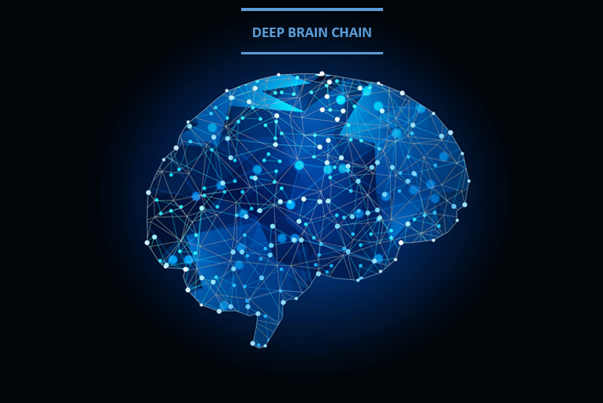
Figure 2.5 The Deep Brain Chain platform publishes regular updates over at DeepBrain Chain

2.7 Smart Contracts
There are currently a handful of smart contracts blockchain platforms that have successfully captured the market. According to Etherscan there are 93039 ERC20 token contracts. Waves, NEO and Stellar, are all developing their own standards in an attempt to challenge Ethereum’s dominance. In a nutshell, smart contracts are programmable “if this, then that” conditions attached to transactions on the blockchain. If situation ‘A’ occurs, the contract is coded to have an automated response ‘B’. This idea isn’t new, and we can find examples all around us, such as in vending machines: if button ‘A’ is pressed, then ‘X’ amount is required; if ‘X’ amount is paid, then snack ‘B’ is dispensed. By adding this simple concept to blockchains, contracts cannot be forged, changed, or destroyed without an audit trail. This is because the ledger distributes identical copies of that contract across a network of nodes, for verification by anyone at any time. When transparency can be guaranteed, these contracts now become possible in industries which would have previously deemed them too risky.
With embedded legal frameworks, smart contracts have the potential to replace and automate many existing paper contracts. Mattereum is working on such legally-enforceable smart contracts. The process of buying a house could become more efficient with no banks, lawyers, or estate agents. Countless hours, expenses and middle-men can be condensed into a few dozen lines of code and an automated product. This automation principle in blockchain-based smart contracts applies to any industry which requires trusted third parties to oversee agreements. Contracts are only as good as their enforcement, so decentralized dispute resolution services are necessary to make smart contracts useful. Early efforts in this direction are utilizing prediction markets and reputation staking tools as with Kleros.
With the rapid development and convergence of AI and decentralized networks, we will begin to see more complex smart contracts develop, such as contracts which are connected to expansive neural networks. The development of these systems could see inconsistencies being found in legal frameworks, resulting in a more robust legal system. Smart contracts would be built upon those legal models, within which AI must comply. It is still early in the development cycle of smart contracts and progress with require collaboration from the legal industry as well as lawmakers in Governments; smart contracts should be seen as the legal rails for the digital world. If tokens are the beginnings of digitally-native money and financial assets; smart contracts are the beginning of a digitally-native legal system. Smart contracts as with distributed computation and decentralized machine learning will automate data in the Convergence Ecosystem creating unprecedented levels of automation within auditable parameters. [6]

2.8 Decentralized Machine Learning
Machine learning is a field within artificial intelligence that focuses on enabling computers to learn rather than be explicitly programmed. More traditional AI approaches based on rules and symbols are not capable of capturing the complex statistical patterns present in natural environments such as visual and auditory scenes, and our everyday modes of interaction such as movement and language. A relatively recent breakthrough in machine learning called deep learning is currently driving progress in the field (however for how much longer is up for debate). Deep learning techniques are ‘deep’ because they use multiple layers of information processing stages to identify patterns in data. The different layers train the system to understand structures within data. In fact, deep learning as a technique is not new but combined with big data, more computing power, and parallel computing it has become increasingly accurate in previously challenging tasks such as computer vision and natural language processing. The most recent breakthroughs in transfer learning and strategic play comes from the combination of deep learning and reinforcement learning as with DeepMind’s AlphaGo.
Machine and deep learning techniques can transform raw data into actionable knowledge; converting voice input into text output in voice-to-text programs or turning LIDAR input into a driving decision. In diverse fields including image and speech recognition, medical diagnosis, and fraud detection, machine learning is equipping us with the ability to learn from large amounts of data. The current machine learning paradigm is where solutions are delivered as cloud-based APIs by a few leading companies. But it is becoming increasingly apparent that this paradigm is not sustainable.
“Data and services are costly to use and can’t sell themselves. It’s staggering to consider all that gets lost without its value ever being realized — especially when it comes to intelligence constructed about markets and data. We simply can’t let all that value be captured by a select few. Fetch has a mission to build an open, decentralized, tokenized network that self-organizes and learns how to connect those with value to those who need it, or indeed may need it; creating a more equitable future for all.“ Toby Simpson, Co-founder, Fetch
As per the theme of the Convergence paper in general, centralized systems suffer from a few fundamental problems: inability to coordinate globally, limits on collaboration and interoperability, and the tendency toward market monopoly and censorship behaviors. With machine learning becoming integral to our lives, centralized machine learning is a threat to both economic competition and freedom of speech.
The Convergence Ecosystem if realized provides global data sharing and marketplace infrastructure enabling AIs to collaborate and coordinate processing in a decentralized way. Removing centralized bottlenecks for heavy computational workloads and helps address latency issues reducing the time needed to train models. On-device training like Google’s Federated Learning model is a technical improvement but lacks the ability for mass coordination using marketplaces and tokens.
Decentralized machine learning not only provides a coordination mechanism for the more efficient allocation of resources, it increases access to machine learning capabilities but allowing anyone to submit models and algorithms and get paid based on quality and utility. SingularityNET, doc.ai and Fetch (a portfolio company) are examples of companies already building the type of decentralized artificial intelligence described. Decentralized machine learning will be the result but would not be possible without the development of distributed ledgers, consensus, identity, reputation, interoperability protocols and data marketplaces.
We must avoid the “disconnected and dysfunctional “villages” of specialization” as Alexander von Humboldt put it and instead aim for a holistic view to see the connectedness of seemingly disparate technological innovations. [6]

2.9 Distributed Compute

Distributed compute refers to computing whereby a complex problem is broken down into more simple tasks. These simple problems are distributed out to a network of trusted computers to be solved in parallel, and then the solutions to these simple problems are combined in such a way to solve the main problem at hand. This is quite similar to how processors (CPUs and GPUs) developed from single-core to multi-core on the same circuit, and multiple cores were used to solve a problem more quickly than one core by itself. Although a simple premise, the other computers need to be trusted for the system to work. Conversely, blockchains and ledgers may be used to create networks of computers through a ‘trust framework’ and to incentivise these nodes to work together, rewarding those who solve these simple problems with tokens that have a financial value no matter how small.Blockchain projects including Golem and iExec are actively solving this problem. Other projects like Truebit are working towards off-chain computation in a trustless way using a prover-verifier game. Verifiable and non-verifiable distributed processing will both be needed depending on the level of trust between participants in the network. Interestingly, we could finally could see the realization of the National Science Foundation Network (NSFNET) project from the 1980s, a supercomputer on-demand for any computing task. Other distributed computing projects like Nyriad are looking to achieve hyper-scale storage processing but without tokens using a concept called ‘liquid data’.
Quantum computing is different to distributed computing in that it looks to solve problems that cannot be solved by existing computers (read: Turing Machines). By using quantum particles, the nascent technology has the potential to test all potential solutions to problems in one go in a single machine, rather than a network of machines. These machines pose a potential threat to blockchain technology because they are reliant on public key cryptography (also commonly used in banking for credit card security) which is made secure based on the difficulty of finding prime factors for huge numbers. These problems would typically take many hundreds or even several thousands of years to solve, but with quantum computers, this timeframe could be reduced to hours or minutes. Companies like IBM, Rigetti and D-Wave, are driving progress in the field.
Parallelization is the thread that ties together distributed computing and quantum computing. On the one hand, distributed computing involves networks of computers that look to solve a problem by solving smaller problems in parallel, while in quantum computing one computer is solving many complex problems simultaneously. In both cases, we can start to rely on networks of incentivized machines to solve computational challenges, rather than servers owned by centralized entities. From an incentivisation perspective, blockchains enable these networks to work efficiently and ‘trustlessly’ with a token powering a marketplace of nodes with computing power. Quantum computers could also form part of these networks, solving the specific problems that the classical computers could not. [6]

